Second Part to : Birth to the dialogue process with the Spirit of the Earth
December 7, 2020 | www.le-verbe-orthosonique.fr

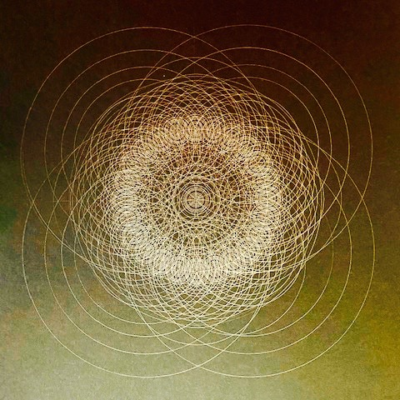

Before addressing the particularity of the planetary positions of 2020 and what they explain about the current disturbances, it is necessary to define the nature of the fields that constitute the Being and the human being.

By incarnating in the human earthly condition, the Being acquires not only a visible and tangible biological vehicle (human body) but also a "causal body".

Before inscribing in the space-time curvature of our solar system and more precisely in the terrestrial atmosphere, the Being is inscribed in dimensions of space, free from the curvature of space-time. The texture of the matrices of space is much more subtle, more powerful than those of the matrices of curved space-time. It is within the matrices of curved space-time that the fields of formative causation very finely observed and identified by Rupert Sheldrake(1) are to be found. This is where the visible forms self-organize. Thanks to the presence of an implicate order of space, certain information from sacred geometries will "secretly" lead the process of forming the tangible world.

The matrices of the Being are inscribed in the dimensions of the A-causal planes of the universe. By allowing itself to be clothed in the matrices of space-time, the first synergies are activated to process interactions between the energies-information-consciousness coming from the A-causal plane and those coming from the Causal plane. A new edge-field is set up, guardian of the just exchange process, guardian of the distribution management of the flow of information and energy which functions as a lock of the subtle planes.

All this "takes its time".

At the moment of conception and the nine months of gestation which will also endow the Being with a physical biological vehicle, the causal body which until then engrams impersonal information, vibrationally preserved, of the memories of the accomplished and the unaccomplished of humanity, will now be informed otherwise. The curvature (effect of mass) that increases by crossing two lines of a family tree begins to condition the causal body with more individualized karmic information. Those that are defined by the way the local group processes them : the parameters of gender, race, culture, social status, political, religious and spiritual conditions.

The particular covers the general, the differences take precedence over the similar.

The densification of the matrices of the causal body, the densification of the biological vehicle, increasingly veils the field of the Being. The forgetting of our A-causal origin largely occurs, leaving just its indelible trace which allows us to remain the divine tightrope walker, weaving between two shores, from shore to shore, the multiple junctions revealing the beauty of the universe manifested within the anthropic principle. A strange dynamic is exercised, border-line of forgetfulness and reminiscence, at the heart of the unfolding of our daily life.
The Being becomes the silent watchman, it lets the personality develop, identify itself with the earthly human condition, it lets it intimately experience the hold of the imposed limits, it lets it question its felt-experiences of doubt, revolt, incomprehension, loneliness, isolation, absurdity but also of hope, dreams, imagination, ideals, quest for meaning etc ... It lets the personality find the path to resilience before powerfully intervening to allow it to awaken.

And even more is possible in our time if we resonate with the fields of possibilities evoked, suggested by the new scientific paradigm since the end of the 19th century.

The planetary mutation announced by the coming of the last two Avatars, signified in the Gospels and accomplished in the text of Revelation, becomes more and more noticeable. It questions human beings in depth. It is a profound call, felt by those who are ready to discover the path of inclusive participatory responsibility. Others will follow. It is not for humanity to evaluate the mystery of the distribution of the impact of this call among us all. Here again, let us lower our eyelids, let us bow down, let us allow the resetting to take place in the depths, let us put an end to premature judgments, let us discover our belonging to fields that establish us in Eternal Consciousness, in order to inscribe ourselves differently in the temporality of our "mortality".

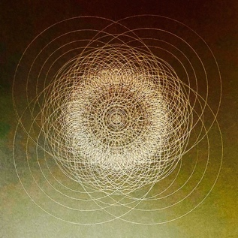

An overhaul of that which was obtained through the lines of resilience that allowed human beings to survive the various traumas by regaining the ability to adapt to the existing world and exercise its talents, will occur when the Being, respectful of the timing of the Spirit of the earth, will powerfully re-emit its fundamental note (singularity).

Human beings then perceive, little by little, signals coming up from the depths of the earth, distributing themselves through their organisms, carrying energy-information of the germ of a redemptive power which has begun its work.

This is the moment when the Being takes over and directly teaches human beings the nature of the purpose they were unconsciously serving. This teaching is direct, without intermediary. The Spirit in the heart of matter expands(2).

It raises the entire memory field engrams in the matrices organizing our substance, stored in the genetic code, also present in the cellular tissues. All the matrices of the human being are impregnated, informed and conditioned by this memory field (we will later see that there are many other memory fields free of any karmic formation.) When they are activated, the mutation processes are experienced consciously.

This expansion could not occur without the presence of the void in the heart of matter. Before densifying (corpuscular state), matter is a wave. Corpuscular states are simply a condensation of the wave. The various forces at work are constantly in intelligent interaction. It is only in the human condition that these corpuscular states freeze, tighten themselves. The corpuscular states of matter (aggregates) are locked by the repetitive mental projection of the observer over generations, who interprets states with replicated, perpetuated keys of knowledge (beliefs) unfounded in the knowledge of the Real and its complexity (ignorance is only the symptom of an immature stage of humanity). This is what is changing.

This expansion restores contact with the presence of the constitutional void. The space that is generated operates a displacement of the cursor in the field of the conscious-witness towards the capacity to process information coming from the micro-nano-movements that permanently occur in our organism and between organisms in a recursive manner. We awaken to physical consciousness, to its intelligence, we discover with wonder how the substance is endowed with a phylogenetic memory. When this becomes consciousness, we no longer doubt that we are the earth, its sky and the skies. From this liberated space, discernment grows considerably:

We become aware of the process of symptom formation (somatic, emotional, psychological, mental). We become aware of our unconscious participation in the formation of the symptoms of the societal and collective body with which we are in conflict.
We take back our responsibility as a subject, we no longer use others to discharge our unconscious guilt by assigning them causal responsibility for the disruption that disturbs the established order to which we are attached.

The veils of judgment will gradually dissolve, the emergence of other capacities of Consciousness will take over in us, between us, new alliances with and through this field, will cleanse the field of social and collective interactions... Preparing the emergence of an unknown and yet constitutional field that humanity in the making will unfold and embody thanks to the dialogue process with the Spirit of the Earth and all that constitutes it.

This birth is the fruit of assumption movements that disrupt the gains of humanity, with which we will cooperate instead of defending ourselves. We will recognize that the purpose of the Spirit of the Earth, at the cost of the trying disruptions with which most have not yet taken the time to engage in a dynamic dialogue (intelligence of critical states), is to liberate humanity from the limitation in which it was maintained until then...

Now it's time to resonate with the particularity of the planetary positions of the year 2020.

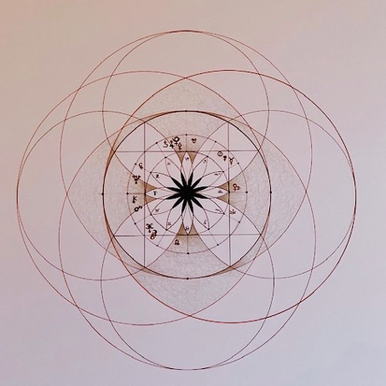

Let's start by putting down the "astrological" information, noting that the names given to the planets coming from a Greek (and Latin) pantheon favor a mythological resonance that the orthosonic approach updates, by rereading the myth with keys of the scientific paradigm shift, in order to go beyond and especially beneath what the symbolic interpretation preciously operated in the past, and prepares in the present.

During the year 2020 several planets were aligned in the sign of Capricorn, the dance steps of an apparent movement, observed from the earth, by the play of retrogradation, to propose several combinations between January 12 and November 12: the conjunction Saturn/Pluto/Ceres framed by Mercury and the Sun in January becoming in November the conjunction Pluto/Jupiter/Pallas, still in the presence of Saturn.
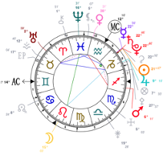

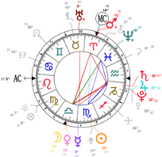

This planetary configuration occurring in the 10th sign (Capricorn) of the zodiacal system, indicates that a maturation of the erosion and emergence processes is sufficiently accomplished to see emerging by its impacts, the power of an innovative field announcing a change in the level of consciousness of humanity : to what birth is it referring to?

To the one of the dialogue process with the Spirit of the Earth which cannot be understood without the key to the law of cycles. It allows us to observe how the progression, the evolution of humanity, is the fruit of complex movements within the atomic matter of the plasma of curved Space-time... We move in a field where a churning is permanently produced, which supports the distribution of energy-information in all the levels of organization of our solar system, and the permanent interactions which occur there.

As much between the different "bodies" that constitute it as well as within the "bodies" themselves... Planetary bodies, asteroids, and more locally concerning our earth with its different kingdoms including our own, and even more locally still: within our different bodies (spiritual, causal, mental, emotional, biological, physical) immersed in a field of an unimaginable plasticity and complexity, from the deepest infinitely small to the deepest infinitely large.

We were for the most part so "cut off", "separated" from the perception of the reality of what founds us, that we organized societies, civilizations that are uncorrelated from contact with the regulators that the intelligence of nature constantly show us. Again this is precisely what is changing.

The exploration of the current Plutonian cycle punctuated by the different conjunctions with the other planets will allow us to better understand the signals emitted by our deep nature, the first signs of the cessation of the hold of this disconnection (symptom) resulting from a temporary natural schize (that which is temporary on the scale of Nature seems to be an eternity to the human mind). As this article unfolds, a deep understanding may emerge, pacification may arise from the depths of substance.

A few words about Pluto: Astronomy tells us that this dwarf planet, mainly composed of methane in the state of ice, approaches the "confines" (same etymological root as confinement) of the field of our solar system.

This planet, unobservable with the naked eye, was discovered in 1930, when astrophysicists grappled with black holes, then dark matter, and dark energy. The mathematician Goëdel dialogued with the mystery of the elusive by discovering and elaborating his two incompleteness theorems, putting man back in his rightful place in the universal order, in terms of the relative power of his capacity to think about complexity. And to restore to Mystery the origin of the principle of Ideation.

The great economic crisis was raging, collective despair favored the growing grip of certain ideologies, the second war was brewing, the Shoah, Hiroshima and many other events still...

Beneath these tragedies, what “Else” was being prepared?

The power of the "Destruction Principle”, one of the poles of the primordial trinity of the various cosmogonies, is clearly at work.

Where are the signs of the unwavering, inseparable alliance between the Destructor and the Preserver, faithful servants of the design of the Creator Principle(3) ?

This is what we are going to methodically apprehend throughout the journey of this article which cannot be short and which invites the concerned reader to live simultaneously that which is set in motion in one's own local field of coherence... Dynamic, interactive reading, whose field of sharing can continue impersonally, a wave of participation propagation engaging the responsibility of everyone.

It is during this cycle which starts in 2020, that this alliance will be able to be recognized by a growing number. Human beings ready to embody this covenant by discovering the operative beauty of recursive consciousness, will support the densification process of the redemptive field.

Pluto takes 249 years to complete its orbital cycle within the specific curvature of our solar system, its deep-seated program needs 8 to 10 human generations to distribute and to begin to bring forth the signs of mutation and a new consciousness.

The attached drawing places the time markers of the Plutonian cycle in which we are currently inscribed. It is during this cycle that this dwarf planet was discovered, in 1930, at 18 degrees of Cancer, the sign opposite the sign of Capricorn.

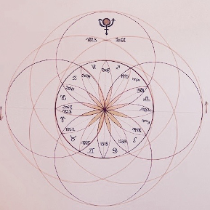

Mythology attributes to Pluto : the guardianship of the cosmic Infernal Regions whose terrestrial counterpart is underground. In Greek this same divinity is called Hades.

Its subtle etymology indicates that the act of lowering the eyelids and bowing the head (humility required to let oneself be guided by the invisible towards the Mystery of the depths) will first energetically and very gently set in motion a tiny expansion of the governing vessel, subtle median line of our spine (Chinese medicine), decompressing the elongated medulla (place of passage from the vertebrae to the skull), gently decompressing the discs, while gently compressing the conception vessel, another subtle median line of our human body (Chinese medicine).

First of all, because: "A journey of a thousand miles always begins with a first step." Lao Tseu

The subtle churning that follows cleanses the first layers of memories that are impregnated in the cellular tissues. Little by little contact with the void is restored, the quality of circulation of Breath-Consciousness-Energy increases, the perception of the locked pockets takes place from the undulatory quality of the field of substance, relativizing their hold, and inviting to "descend" deeper, towards the fields of the infinitely small, where the redeeming power is at work.

The journey towards the infinitely small, passing through the constituent layers of our substance that veils our Being will be able to continue.

When it comes to Pluto, it is always physical and concrete, and at the heart of incarnation. The volatile sensors are no longer sufficient to support an understanding of what is happening. The re-enfolding of these volatile fields is activated, the expansion of the deep-seated fields are perceived after critical states manifested themselves through forced passages into dark nights of the soul, that are trying and also redemptive once crossed(4).

Many documentaries currently offer the viewer, thanks to computer-generated images, a reflexive projection of what makes us complex. These new morphic fields of the cyber-sphere participate in a silent process of collective awakening. It is information that engrams itself into the volatile fields of reflexive consciousness that will then be tested by the amplification of the assumptive movements of matter, so that this emerging knowledge becomes pure knowledge.

It is a long natural initiatory path where erosions and emergences powerfully combine in an alchemical way that has begun for humanity. This is the first step in a conscious and collaborative participation in the planetary mutation of species.

Without the technological advancements enabling us to build gigantic telescopes, the observation of the presence of this dwarf planet beyond Neptune would not have been possible. If for now, the evocation of Pluto/Hades produces an uprising in the memorial field of the collective unconscious, of a wind of dread, terror and death, the uncovering process that is at work (Apocalypse) will in due course bring out the splendor hidden behind this wall of Planck that was also manufactured by the same collective unconscious. Technological advances are impressive and unquestionably make access to information about the constitution of the matter of the universe possible for everyone.

What these technological advances allow as exploitation is mostly not yet supported by the physical awakening of recursive consciousness.

Humanity, through a change in the vibratory level of the subtle bodies of the various spheres of the earth, has benefited in particular from a volatile expansion of consciousness, increasing its capacity to conceive through and thanks to technological developments, that other forces, other dimensions are at work. Their discoveries are at the heart of building the current paradigm shift.

Nature always takes its time, humanity not yet. The grip of the mass of its 'karma to conquer' still compels humanity to project itself forward. Its impatience is karmic and symptomatic of the cleavage that it undergoes without being able to submit it to the intelligence of the power of Nature. Justified by a thirst that seems inexhaustible...

The gaps are widening, the systemic critical states are amplifying, signs announcing a powerful rebalancing of the power of nature brought about by certain upheavals of its reunifying fields from which we have much to learn.

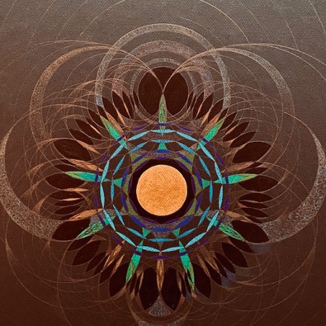

Let's continue with Saturn/Chronos in conjunction with Pluto/Hades.

The attached drawing is to inscribe within the Plutonian cycle, the specific distribution rhythm of the churning of information-energy, by its combination with the Saturn cycle, without omitting the interaction with all the other orbital fields of the other planets which are not specified here.

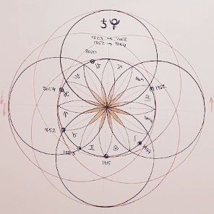

Some words for Saturn/Chronos
Sat-Urne, the Urn of Sat.
Sat is a Sanskrit word for Spirit.
Saturn is the guardian of the memories of what has been accomplished by each generation thus far inscribed in the old paradigm system of thinking. It ensures with rigor and discernment that the chain of union in which we are enrolled is recognized: each generation benefits from what previous generations accomplished, from that which they prepared. Subsequent generations continue the work that is possible at each stage of the evolutionary process.

Saturn is the divine intergenerational mediator. Its ability to conserve karmic information (memory of the unaccomplished / accomplished causal chains) is at the service of the growing awakening of the intelligence of the deeper cyclic temporality. The impression that time is suspended, stopped on repetitive images of known scenarios has given rise to a feeling of fatality in the reflexive field of mental consciousness. In reality, nothing is stopped. In the term 'humanity', the resonance with 'humus' should be able to help us focus attention on the alchemical process of the decomposition of impressions by the intelligence of the living, where the germ of the awakening of recursive consciousness develops. Metabolization occurs harmoniously when the dynamic adjustment between anabolic and catabolic is balanced.

The Saturn/Pluto conjunctions invite us, from cycle to cycle, to experience within our substance the disorganization of the veils of ignorance, that until then obscured the perception of the inseparable alliance (dynamic of permanent adjustment) between the constructive principle and the destructive principle, guaranteeing the fulfillment of the plan of the creative spirit in the heart of the physical world, material of the manifested world, requiring the participation of a multitude of generations in order to be realized.

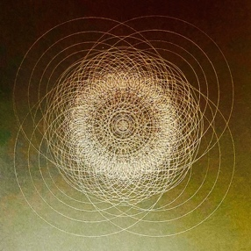

Let's continue with the conjunction Ceres /Pluto

Ceres (discovered in 1801) is part of the asteroid belt between the orbital field of Mars and the orbital field of Jupiter.

At each of their new conjunction, the dialogue with what the myth of Persephone proposes can enlighten the scenes of everyday life in a dynamic and non-fatalist way.

What does the first level of information of this myth tell us?

When Hades/Pluto, guardian of the underworld, kidnapped Proserpine/Persephone to make her his wife, her mother Demeter/Ceres went in search of her, forsaking the crops of the Earth...

For those who are on the path of discovering the process of the embodiment of the paradigm shift, the powers attributed to the various personality-divinities of the Greek and Latin pantheon, are recognized as informational-force fields, highly differentiated, interconnected, whose dimensions from the infinitely small to the infinitely large testify to a complex order.

The current amplification of their interactions produces movements that propagate through every level of organization of the Earth's spheres. The true origin of the visible, tangible disturbances on the surface of our daily lives (which occur at all levels: physical, somatic, emotional, mental, spiritual but also societal, systemic) needs to be recognized by those who can. Thus a morphic field of a new consciousness will densify. The quality of this consciousness is to correlate the visible movements interpreted by a mechanical causal mind reader, with the movements of the depths. This field of consciousness is established in a cruciform field. It becomes the increasingly powerful support of the field of the collective unconscious that still vibrates on the note of the old paradigm, in an apparently dominant way.
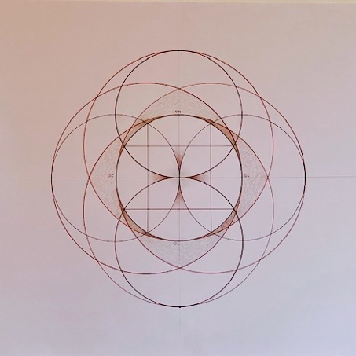

Several resonances of this innovative field of consciousness dialoguing with the mostly painful scenes at the start of 2020:

"Confine" rhymes with confinement,

What does it subtly propose by suspending, for many, the usual activity that consequently modifies the production results ?
1. To discover other unexplored fields of available resources
2. Experiment emerging disruptive modes
3. To receive the karma of fear, doubt, the inconceivable, terror, suspicion etc. that are raised, from which one cannot look away, now that the hyperactive modes have been hampered
4. Let them emerge, discover that they are inscribed in each one of us, become aware of the field of the causal body of humanity, which is a profound inheritance transmitted from generation to generation, awaiting recycling, redemption
5. To stop constantly judging, to be born, by the increased fields, to humility, to patience, to compassion, to be born to group consciousness, in order to prepare the matrices allowing the emergence of what democracies will really become
6 ...
7 ...
8 ...
And many other fertilizing, transforming resonances.

This second part has highlighted some information concerning an approach to the subtle constitution of the human being, some information on the planetary positions at the beginning of the year 2020 (conjunction Pluto/Saturn/Ceres of January 12, 2020).

The third part, currently being written, will continue to highlight some information on the planetary positions at the end of the year 2020 (conjunction Pluto/Jupiter/Pallas-Athena of November 12, 2020 + conjunction Saturn/Jupiter of December 21, 2020).

A fourth component, in preparation, will begin to bring together the resonances activated by the evocation of this information, and thus foster the birth of the dialogue process with the Spirit of the Earth.

It's a long way... At the pace of the unpredictable, in the multiple hands of the invisible who is also driving this writing process...

(1) Reread in Orthosony II: "The field of recursivity" one of the satellite texts concerning Rupert Sheldrake's work
(2) Reread in Orthosonie I,The innovative field of human interactions: Shri Aurobindo's satellite text on the triple transformation
(3) The primordial tri-unity is redefined in orthosony II, the field of recursivity, satellite text
(4) Orthosony I the orthosonic approach of the singularity

Infinite gratitude to the Spirit of the Earth,

Thanks to all,

Thank you to the visitors of the site, their own resonance participates in the deployment in each one and between all of us a wave of propagation weaving the underlying fabric to that of the net.

A very special thanks to all the beings who have participated and continue to participate for many years, engaged in the self-healing process that we discover together during the deployment of the workshops. Since, already and only, for about forty years, by the operative power of the Spirit of the earth, we are physically born to the recognition that it is this Spirit in alliance with our Beings who teaches us, ploughing our "inner" lands, seeding them with new root forces, leading the awakening to the perception of innovative fields, safely leading through the disturbances which are amplifying more every day, orchestrating our synergies in an increasingly efficient way...

Let us give thanks to His Silent Breath....

